Energetic movements
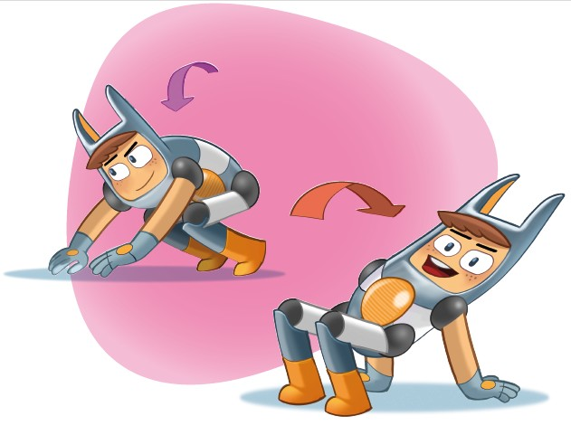

I put my hands on the floor. I walk my hands forwards. I walk my hands behind.

Energetic movements

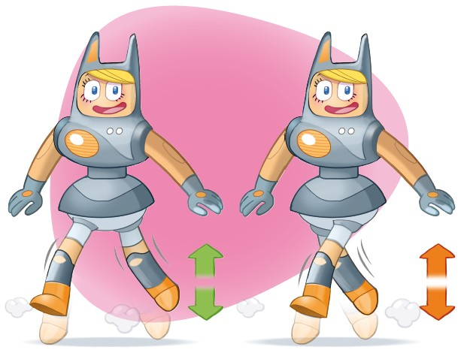
I put one foot in front. I jump and swap my two feet.

Energetic movements

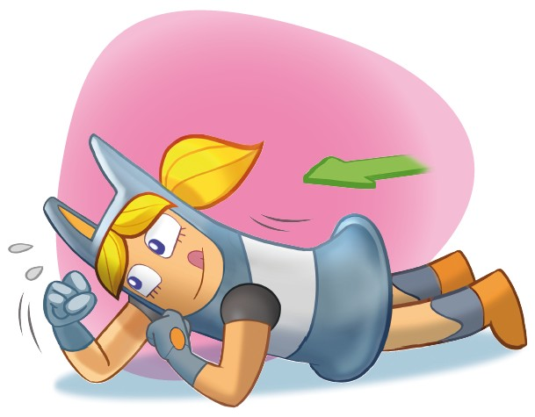

I lie down. I crawl on my elbows.

Energetic movements
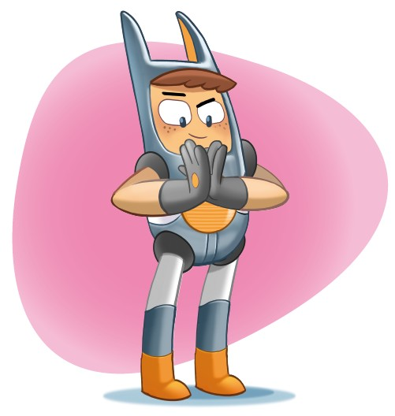
I grip my hands. And I let go.

Energetic movements

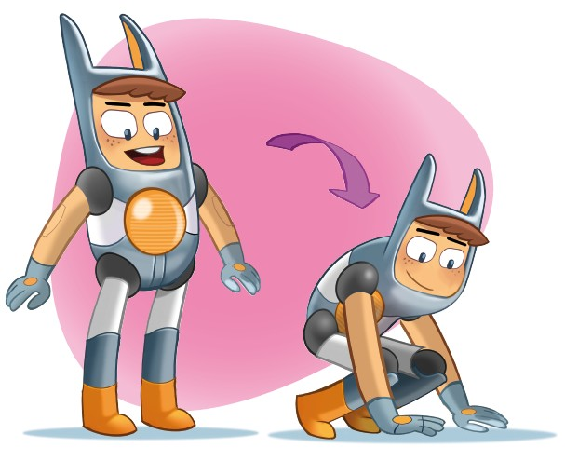
I crouch down and put both hands on the floor.

