Dynamic exercises
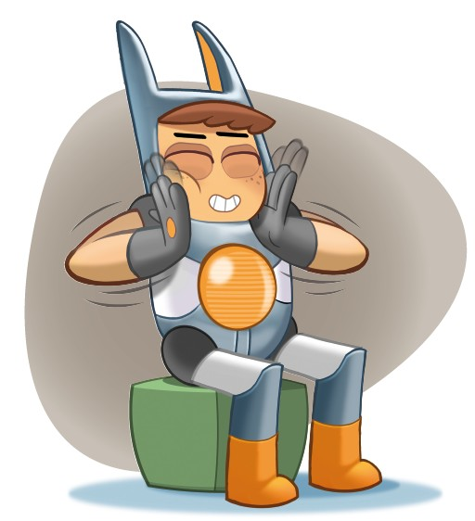
I tap with my fingertips and count to ten.
Dynamic exercises
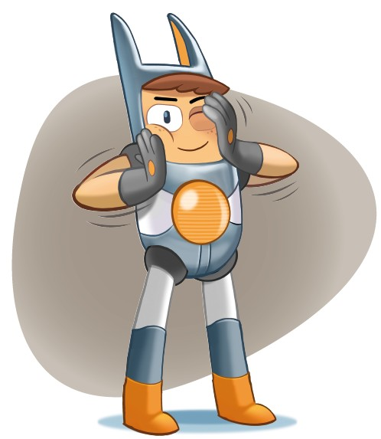

I wash my face.
Dynamic exercises
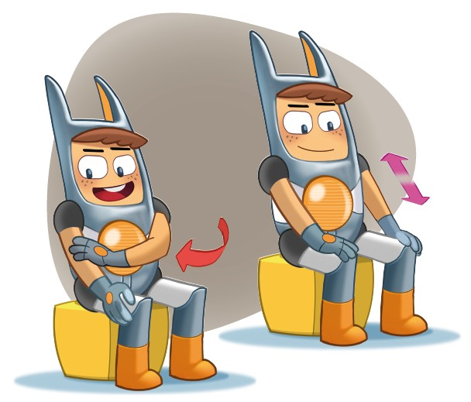
I wash my arms and my legs.

Dynamic exercises
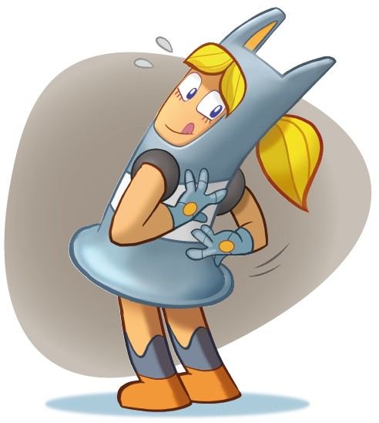
I wash my back.

Dynamic exercises
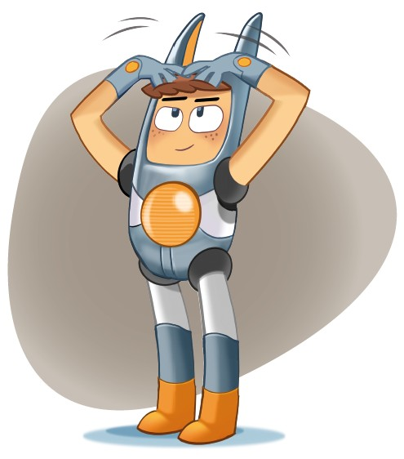
I wash my hair with my fingers.

